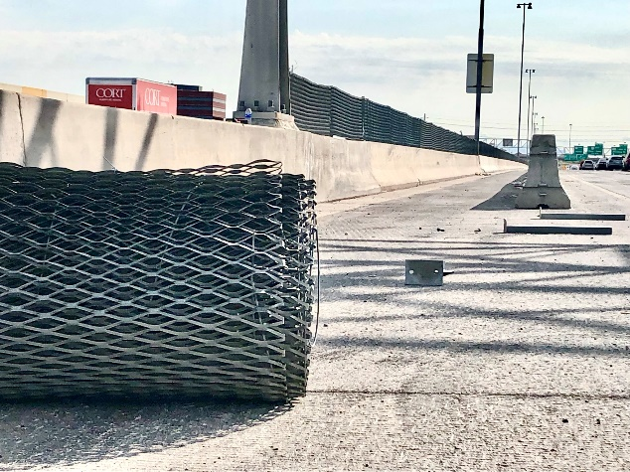 | To prepare for upcoming construction, crews began removing the glare screen near 40th Street.
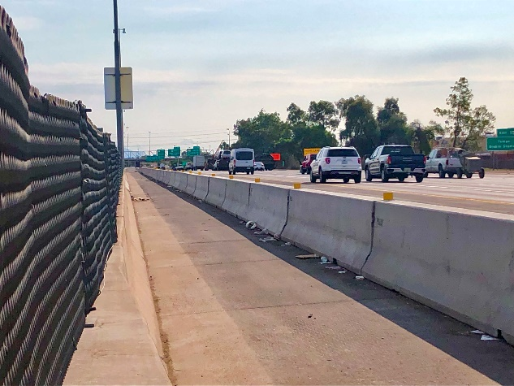 | Glare screen on I-10 near 40th Street before crews began removing it.
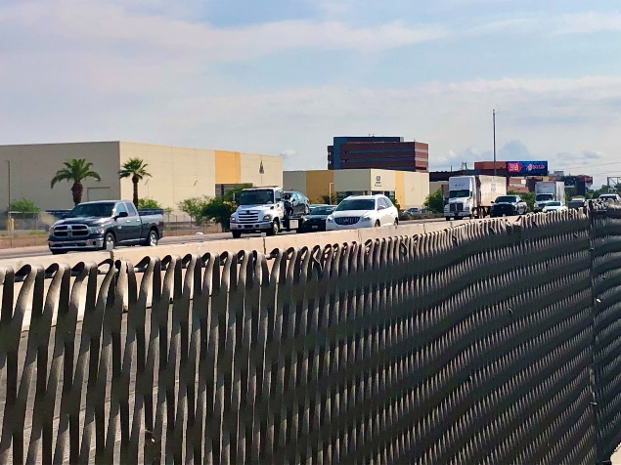 | Glare screens help block out headlight glare of oncoming traffic.
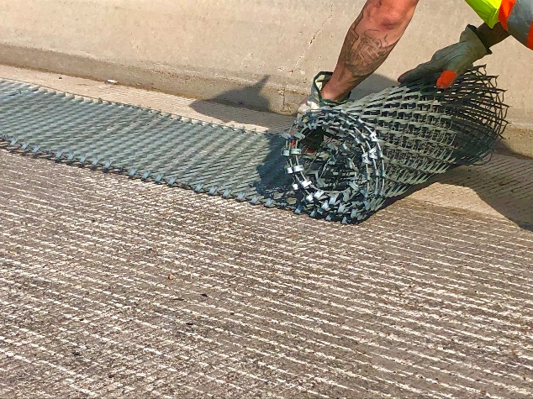 | Worker rolls up glare screen after removing it from the I-10 median wall.
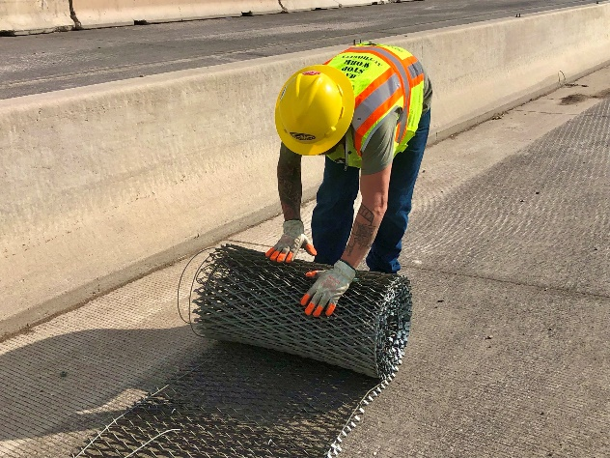 | Worker rolls up glare screen after removing it from the I-10 median wall.
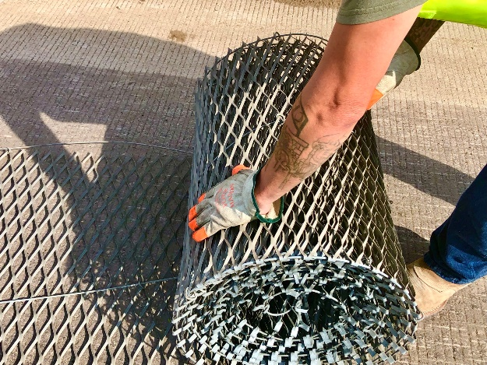 | Worker rolls up glare screen after removing it from the I-10 median wall.
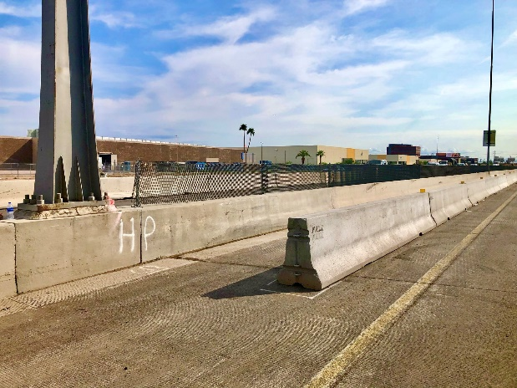 | Glare screen on I-10 near 40th Street before crews began removing it.
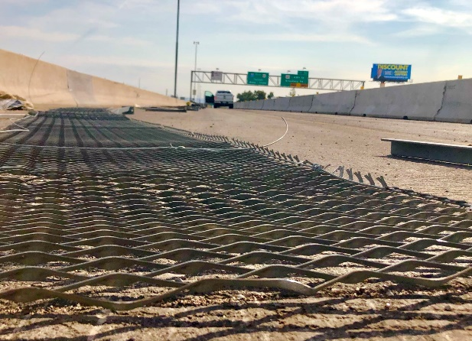 | Glare screen removed from the I-10 median wall.
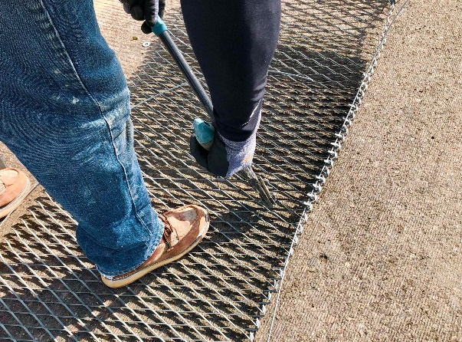 | Worker prepares removed glare screen for disposal.

